Abstract:
The continuous flashing of light from the wind farms not only disturbs the people around but also the environment. The aim of the present study is to reduce the light emissions from continuous flashing of wind turbines in the vicinity of flying objects. This can be achieved with viewshed analysis by giving the optimal position of wind turbine within a certain radius, so that the flying object within that radius is detected by the toggling light of wind turbine. This research uses QGIS tools executed through Python to perform the viewshed analysis. The output generated from viewshed analysis is then sent to a visualization GUI to develop and maintain wind farms.

Keywords: Viewshed Analysis, QGIS, Wind farm, GUI, Wind turbine

TABLE OF CONTENTS
Abstract
- Introduction
  - Motivation
  - Purpose and Scope
  - Uses of Visibility Analysis
  - Thesis Summary
- Fundamentals
  - Elevation Model
    - TIN
    - Raster DEM
  - Geo TIFF Data Format
  - Viewshed Analysis
  - Different output types in Viewshed Analysis
  - Chapter Summary
- State of the Art
  - Different Approaches
    - QGIS
    - ArcGIS
  - The on-demand night-marking system
  - Chapter Summary
- Methodology
  - Extraction of Topographic Features (Input parameters)
  - Viewshed Analysis Calculation Algorithm
  - Different Tools of QGIS
  - Chapter Summary
- Observation Points
  - Selection of the Observation Points
  - Elevation of the Observation Points
  - Target Height
  - Chapter Summary
- Discussion
- Results
- Conclusion
- Future Work
Bibliography

ABBREVIATIONS
DEM Digital Elevation Model
GIS Geographic Information Systems
QGIS Quantum Geographic Information Systems
PyQGIS Pythonic Quantum Geographic Information Systems
TIN Triangulated Irregular Network
DTM Digital Terrain Model
SRTM Shuttle Radar Topography Mission
NED National Elevation Data

Chapter 1 Introduction
Viewshed analysis is one of the most common and pioneering features in GIS Software packages. It is used in various fields and considered to be very futuristic for both practical and aesthetic applications.
Viewshed is considered to be the area which is visible from a specific point and certain altitude. The technique of finding these viewsheds is termed as viewshed analysis or the so-called visibility analysis. To determine and estimate the visibility of a target point, each point between the viewpoint and target point is well examined for the line of sight. There can be multiple factors hindering the visibility of a point from a particular location namely terrain features like hills or buildings, height of the observer, the viewing radius etc. The output is basically an image representing the visible along with the invisible areas (each differentiating with different colour) as shown in the below figure on the terrain as a lead for decision support.

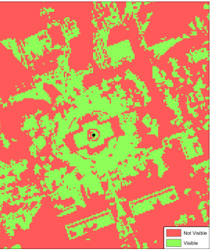
Figure Name: Viewshed Analysis
Viewshed Analysis is a very common and sophisticated practice where various kinds of viewsheds are implemented, each in return to meet different needs. Each application of viewshed analysis gives rise to unique analysis algorithm. As the input values and parameters differ from application to application, there will be a notable change in the algorithm.

  - Motivation
The introduction of the on-demand night-time marking systems is to avoid the obstructive effects of continuous flashing lights during nighttime which will potentially lead to less attraction of birds and other animals and also a reduction of energy consumption. The main goal of this study was to create a GIS model that could calculate the visibility between potential ground antenna locations and a moving aircraft.

  - Purpose and Scope
The main purpose of viewshed analysis is the on-demand night-time marking systems. The future windfarms need to be equipped in such a way that it reduces the continuous flashing of light at night, for which the optimal position of the windfarm needs to be determined.
The aim of this study is to make use of viewshed analysis for wind farms as a helpful tool for the on-demand nighttime marking system. Viewshed analysis can also be done on a random location to check whether a wind turbine can be placed in the future or not. The objective of the research is to find an algorithm to determine the viewshed analysis for the existing wind turbines which determines the visible and non-visible areas within a particular radius.
This study has been limited to the raster-based tiff files. The observer points which in our case are the wind farms are taken as the latitude and longitude positions.
The automation of the viewshed analysis is done by the Pythonic QGIS (PyQGIS), where QGIS is an open-source software tool embedded in Python. The tool operates directly on the pixels of the raster data and produces the output in the form of visible and non-visible areas.

  - Uses of Viewshed Analysis
Viewshed analysis is not restricted to one field. It is widely used in various fields ranging from earth sciences to telecommunications. Initially, line of sight analysis has been used for military purposes in determining the optimal location for the battle, so that it can be visible from most of the sites. It is also very helpful in sending signals at the time of emergency.
Its use has also been extended to telecommunication industries in finding the best site for cellphone tower location to have an unobstructed view of other cell phone towers so that the transmission occurs without any hassle.
In tourism and recreation areas, it is used to enable an unrestricted view of a historical place or landscapes from a distance.
In construction sites, viewshed analysis is used to get the best view of a building through windows, in estimating the optimal position of watch towers with maximum coverage in all directions and also aids the CCTV positioning.

Viewshed analysis assistance in MER (Mars Exploration Rover) project
When NASA needed to find the best possible sites for landing the Mars rovers, they took help of an analysis, part of which included a viewshed of the selective possible sites. The viewshed in this case indicates the locations which might or might not be visible for the landing of Mars rovers.

  - Thesis Summary
The Structure of the thesis is as follows: Chapter 2 consists of the background about digital elevation model, viewshed analysis and different types of viewshed analysis with different outputs.
Chapter 3 consists of different approaches to perform viewshed analysis and the reason for choosing our approach. It also contains the reliable information regarding companies performing the on-demand night marking systems.
Chapter 4 deals with the methodology, input parameters and the implementation technique of the algorithm.
A detailed description of the input parameters and the criteria for those values is provided in Chapter 5.
Chapter 6 discusses the approach and the results evaluated in Chapter 7.

Chapter 2 Fundamentals
In this section we try to define three main functionality and vocabularies which are used in Viewshed analysis. The name of these terminologies differ in different applications. They are listed as below:
Line of Sight:
Line-of-sight analysis defines whether two points in space are visible to each other. In routine, only the initial and terminal points needs to be recognized, and sometimes the elevation of the observer is also taken into account. The software divides the line into segments that are visible from the initial points and segments that are hidden behind an obstacle [35]. In some application, a combination of this method with terrain profile is done, which also creates a color distinction not just in the line segment but also of the curve which denotes the profile.
Viewshed:
The difference in the elevation of the two points i.e. Observer point and the Target point, is produced. This is called Viewshed, and this Viewshed is generated over a DSM using an algorithm. Through the Line of Sight, we can determine the Visibility of the Target point. In order to do this, each cell or point which lies on the line connecting the Target and the Observer point must be examined by Line of Sight. The value of the cell is very critical in this case. The cell which is of higher value between the above mentioned two points, then it is blocked. This is the case when we term the Target point to be “Not Visible” [36]. This is the brief explanation of the term Viewshed and in the further section of the thesis, it will be described in depth.
Visibility:
Visibility is the last method offered by QGIS. The other phrase which is used in different application is Multiple Viewshed. This visibility function is very significant to answer some of the questions which are essential in our study.
Q1 "What places are visible from the given observation point?"
Q2 "What is the number of observation places, the object/point is visible from?
To understand this Visibility functionality we try to demonstrate it with an example:
We can illustrate this functionality with an example:
Several important buildings are analyzed (e.g. churches) and it is examined from what places in the area of interest the highest number of these buildings is visible at the same time. A detailed examination of the result shows that it is only a combination of the visibility from individual break points in the line. [37]

2.1 Digital Elevation Model
Viewshed analysis essentially requires the elevated data of a terrain as a primary input for the targeted. The elevation model can be extracted through Radar, Lidar, Stereo photogrammetry etc.
DEM is also used to determine various features on the terrain such as drainage networks and channels, drainage basins and watersheds, peaks and pits and other landforms.
Digital Elevation Model is a 3-Dimensional representation of the Earth’s data which enables distinct view of peaks, valleys, natural habitants with ascents, descents and other features. The digital elevation model plays a very crucial role in the viewshed analysis, as it uses DEM as an input on which the analysis is performed.
Almost all the available digital elevation data is stored in raster file format. There are multiple distributors for these digital elevation maps. U.S. Geological Survey (USGS) consists of National Elevation Data (NED) which is a combination of numerous data resources and is available in Geo TIFF, Arc GRID, Grid Float and BIL with accompanying textual metadata and SRTM (Shuttle Radar Topography Mission) where the dataset is collected by means of a radar system using the technique of interferometric synthetic aperture radar covering almost 80% of the total Earth’s surface.
The main difference between NED and SRTM is that SRTM is based on Digital Terrain Model (DTM) which includes only surface of the earth excluding objects like buildings, plants etc. whereas the elevation of NED is DEM which includes all the objects in analysis.
Most common uses of extracting digital elevation model are extracting terrain parameters, modeling water flow or mass movement for the sale of landslides etc., for the creation of the relief maps and physical models, rendering of 3-Dimensional visualizations, satellite imagery etc.
Digital elevation model can be represented with either TIN (Vector) or Raster DEM (Raster data). We can see them below in a detailed manner.

2.1.1 TIN
The Triangulated Irregular Network (TIN) dataset is referred to as a vector of points with an irregularly positioned triangles representing a surface, the vertices of which are formed from field recorded spot elevations by various means which include surveying through conventional techniques, GPS RTK (Global Positioning System Real-Time Kinematic), photogrammetry, etc. Triangulated irregular networks are excellent for analyzing and describing general horizontal distributions (x and y) and relationships since they are associated with 3-Dimensional data (x, y, and z) and topography.
Depending on the difference in elevation, number of triangles plays its part accordingly. Fewer triangles are needed to represent an area with little or no difference in elevation and relatively more number of triangles are needed to sufficiently represent an area with large difference in the elevation. Also large difference in elevation requires more effort to process the analyses.
Various sorts of file formats exist for saving TIN information along with Esri TIN and others such as ICEM CFD and AquaVeo. ICEM CFD is a cumulation of basic tools and methods for creating meshes with Ansys ICEM CFD Tetra-Prism and HEXA.
2.1.2 Raster DEM
A DEM is a pixel-based raster GIS layer in which each pixel represents the height above the ground. The terrain is separated into rectangular geographic sections of equal size. It's a grid of squares with each cell representing a small section of the map. The information about the subarea is contained in the cell's value. The smaller the subarea represented by a cell, the higher the raster's resolution. This means that a higher resolution will give more accurate representation of the area. There will be additional data points in the raster. Because the height of a small subarea is represented by the value recorded in a cell, it will not be an exact value for every actual point in a terrain. There are several methods for sampling the topography in order to determine a cell's elevation. For example, the elevation of a point in the center of a cell, an average across the entire subarea, the subarea's minimum elevation, the subarea's greatest elevation, or the subarea's center elevation might all be used.
The TIN and raster DEM, as well as the TIN with triangular representation and the Raster DEM with rectangular grids, are depicted below.

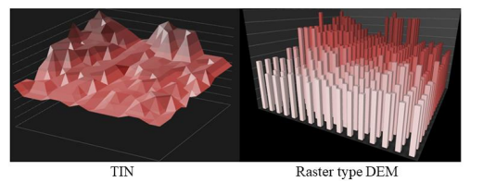
Figure Name: TIN and Raster type DEM

2.2 TIFF Data Format
The Tag Image File Format (TIFF or TIF) is a computer file format created to store raster graphic images along with the accompanying geographic information. TIFF is an open public domain, and non-proprietary format which was created by the Aldus Corporation in 1986 for use in desktop application. Currently, TIFF is maintained by the Adobe Systems.
TIFF is one of the few public-domain formats that supports tiling, compression, and other geographic metadata enhancements. It includes header tags which consist of the size, definition, arrangement of image data and image compression applied on that specific image. It holds both lossless and lossy images.
In the current project, all the raster images starting from the Digital Elevation Model to the viewshed analysis are stored in TIF file format. It contains the geographic metadata to a point upon which the viewshed analysis is carried out.

2.3 Viewshed Analysis
Viewshed analysis is the computation of terrain visibility from a certain observer point, which involves determining what sections of the terrain are visible to the observer if he is placed at a specific location on the terrain. These calculations are carried out in the context of a digital terrain representation.
Viewshed analysis basically provides the line-of-sight analysis for a viewpoint by including various surfaces like ground, trees, buildings and other landscapes. It is a digital elevation model denoting the visible and obstructed points. A target would be visible if a Line-of-sight analysis is drawn from the observer point without obstruction from any of the terrain features or any other factors.
Viewshed analysis takes various input parameters into account such as coordinates of the observation point where it is supposed to be placed, Digital Elevation Model, radius for which the point needs to be covered, observer height in meters and the target height where the height value is added to all the terrain areas. This is crucial to denote the visibility from the observer point.
Viewshed analysis depends directly on the DEM as well as the increase in the observation elevation resulting in an increase of the visible part’s surface area. The resolution of a raster DEM which is used to model an area of the specified terrain will have a strong impact
on any viewshed analysis performed on the DEM. Since each cell can only contain one height value, the most obvious impact comes from the generation of the raster. The value will be approximately the area which the cell covers. The higher resolution raster DEM provides comparatively a closer approximation to the physical terrain since each cell there represents a smaller area.
In a visibility analysis, elevation offsets for both the target and the source can be defined. This produces a binary surface over the terrain that shows viewable locations, or a viewshed of the source point. The viewshed can also be regarded as a response to the query, "From where can I see the source?" There may be instances or interpretations of visibility in which the source can see the target but the target cannot see it. The source or the observer point, can also have an angular range defined. Then, for the analysis, only the target cells that fall inside the defined field of view should be examined. This parameter can be used to specify the observer's direction of view
The restriction of the set of target cells is another typical characteristic. A group of towers, for example, would form a collection of distinct and presumably unrelated cells. An aerial target, on the other hand, can be thought of as the collection of cells that make up the target.
A vector layer of points, lines, or polygons can be used to deliver target data. Another option is to use the raster data's elevation values as a selection criteria or to offer a separate raster map for that purpose.
Essentially, defining how an item, such as a tower, is visible is critical for the visibility computation. The calculation must be based on the terrain elevation below the target point if the tower must be fully visible from the base to the top. If it is enough for only a portion of the tower to be visible, the integration of the actual elevation of the target point into the visibility analysis has to take place.
Apart from the binary viewshed, the analysis can be multiple viewshed or cumulative viewshed.
For combination of all layers in Multiple Viewshed is Multiple viewshed combines all layers accomplished for every target point using union operator. The result is a binary grid where 0 means target visible while one 1 means target visible from the union of single viewshed raster’s. It denotes the viewshed analysis of more than one point at the same time. Multiple viewshed is completed over a specific area containing one or more object position according to the area of interest. In order to perform the multiple viewshed analysis over a specific region, the elevation data is necessary. This elevation data is stored in one or more data sources. Elevation data is obtained by combination of the height data and the elevation from multiple sources. Multiple viewshed analysis is performed by computer analysis of lines of sight between points in a relevant area and multiple object positions [39].

Cumulative viewshed analysis is a GIS-based method for exploring whether the two points i.e. target and the observer are visible to each other and also its archaeological application. It is used to know the intervisibility between the related sites inside a landscape. It is not a very complex method , hence can be considered as robust. Another way along with the Cumulative analysis, called Total analysis is also used for viewshed and to study visual landscape. The summation of all the grid is done by the means of map algebra. Cumulative Viewshed allows to take into account of multiple points of view and provides further information about the number of points that can be seen in a specific zone. It is no more a binary grid, but it indicates, for each cell, the number of observed objects. The limitation of the Cumulative viewshed is that it cannot show the visibility of a specific target from a certain cell. But unlike the visual analysis; which is done from several sides; the cumulative analysis is applied to a single site. The thing that makes cumulative the viewshed from just one site is the fact that the observer is understood like a group of points over the site's whole surface [38]. The main aim of Cumulative Viewshed is to calculate the intensity of view from site and also to recognize how many times the particular area is seen.

The below picture depicts the difference between the multiple viewshed and the cumulative viewshed.
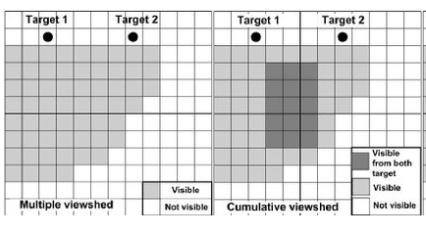
Figure Name: Multiple Viewshed and Cumulative Viewshed
2.4 Different output types in Viewshed Analysis
Viewshed analysis gives rise to three different types of output namely Binary Viewshed, depth below Horizon and Horizon viewshed.
Binary Viewshed: The basic idea of the visibility analysis is to test whether a particular location is visible from a provided observer point or not. Binary viewshed is a visibility map with each data point of a terrain model assigned as true or false for visible and non-visible points of that terrain model. A visible location is then recorded as 1 and the area which is totally out-of-view is recorded as 0.
Depth below Horizon: The visibility test query for a particular locations yields in a yes or no answer, known as Boolean Raster or Binary viewshed in GIS software. But for the all invisible locations, an information is needed to know how much to raise the ground, in order to make them visible. Some places within a margin of a meter or less below the local horizon. This can be considered as marginal and could be termed as possible visibility, given the usual error margin of typical elevation models. When analyzing urban plans, this measure could be used to determine the visual impact of proposed constructions: where and to what extent would buildings project from horizon line (aka skyline) [40]. Along with the visible and non-visible areas, Depth below Horizon will also provide the depth value of invisible portions of the terrain. Then the produced value would be used to denote the height which is needed to be attained by a terrain in order to be visible from the specified observation point. This is now available in QGIS 3 and is termed to be as Depth Below Horizon, previously called as “Invisibility” [40]. But unlike some other methods, the multiple Depth Below Horizon cannot be combined simply by adding some values. There is a special algorithm which is dependent on the deepest and the shallowest values for a specific point.

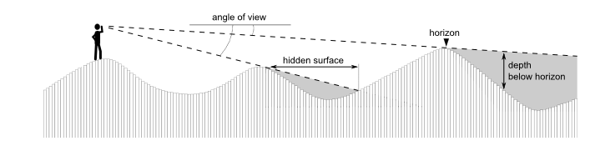
Figure Name: Depth Below Horizon
The above diagram shows the depth below horizon. The areas which are invisible from a point because of a hill or a slope can be made visible with an addition of a depth value to the analysis.
Horizon Viewshed: The outer edges of the viewshed can be traced with the help of a Horizon Viewshed. From a chosen observer point, it represents all the points appearing on the horizon. It aids in determining the non-contiguous visible areas.
In our research we have limited the viewshed analysis to just binary viewshed since we deal only with the visible and non-visible areas of a wind turbine but not with the height which needs to be increased in order to be visible from the observer point.

  - Chapter Summary
This Chapter essentially deals with the background of Digital Elevation Model and its different types, TIFF Data Format along with the viewshed analysis and its different output types.

Chapter 3 State of the Art

3.1 Different Approaches
GIS software comprises of different kinds of tools to perform viewshed analysis and it is getting more competitive day by day with its advancements and increasing tools with subsequent updates. Here we mainly focus on QGIS and ArcGIS, which are two different approaches but almost similar with just a few differences. Both are geographic data frameworks which deal with maps and geographic data. Viewshed analysis has become the standard terrain analysis in GIS packages such as QGIS and ArcGIS. Both the systems offer numerous identical functions.

3.1.1 QGIS
QGIS (Quantum GIS), developed by Gary Sherman in 2002, is an open-source, free desktop application which helps users to analyze and edit the spatial information. It also aids in composing and exporting graphical maps. The Source code developed in QGIS can be easily modified by a developer or any other person. QGIS is limited only to a desktop application. A mobile version for Android was however under development as of 2014. QGIS relies on the POSTGIS which is not only good for small projects but also works well with the big data files.
QGIS supports both raster and vector layers where vector layers are often represented as a point, polygon or line features. Multiple raster images, such as tiff, sdat, and others, can also be georeferenced.
QGIS integrates with MapServer , POSTGIS and GRASS GIS. QGIS can also be used with Kosmo and SAGA GIS.
QGIS supports coverages, shapefiles, personal geodatabases, MapInfo, dxf, POSTGIS, and other formats.
QGIS has been translated to 48 languages and is widely used globally in professional and academic environment such as National Geospatial-Intelligence Agency, New Zealand’s Land Information public service department, US National Security Agency, etc.

Differences | QGIS | ArcGIS
License | Available for free | Paid License
Operating System | Windows, Linux, Mac OS, and Android | Windows and Linux
Versions | Multiple versions can be installed in the same system | Only one version is allowed
Tools |  | Paid licensed tools
  Allows few free tools
File format accessibility | Supports all formats | Supports only f file formats
Source Code | Open Source | Closed Source code
Processing time | Less | Longer processing time
Reliability | More reliable | Comparatively less reliable
Mapping functions | No advanced mapping functionalities | Many advanced mapping functionalities
Plugins | Many plugins available | No plugins available

Table 1: Differences between QGIS and ArcGIS

3.1.2 ArcGIS
Unlike QGIS, ArcGIS is the paid license and is mostly used for commercial purposes, developed and maintained by ESRI. It was first released in 1999 as a command line GIS with sole purpose to edit the spatial data. ArcGIS is a closed source code and hence can only be modified by the developer. The execution time is very high in ArcGIS as it consumes in more time in producing the end results. The data storage methods essentially depend on the file based shapefiles and Geo based databases which is suitable for small projects, but becomes difficult when dealing with large projects.
Geodatabases in ArcGIS are of three types:
1.File geodatabase - the File geodatabase stores information in a folder with a .gdb extension. It supports a single editor and virtually has no size limit.
2.Personal geodatabase- the Personal geodatabase also supports a single editor but has a 2GB size limit virtually unlike File geodatabase. It stores data in Microsoft Access files with the help of a BLOB field. Database administration tasks such as managing users and creating backups could be executed through ArcCatalog and ArcGIS Pro. Personal geodatabases based on Microsoft Access can run only on Microsoft Windows.
3.Enterprise geodatabase. Enterprise geodatabases are multi-user geodatabases which sit on top of the high-end DBMS such as DB2, PostgreSQL, Microsoft SQL Server, Oracle and Informix to handle database management aspects, while ArcGIS deals with the spatial data management. Enterprise geodatabases are cross-platform compatible and support database replication, versioning and transaction management. They can run on Windows, Linux and Solaris.
ArcGIS Desktop includes ArcScene, ArcMap, ArcGIS Pro, ArcToolbox, ArcCatalog, and ArcGlobe, among other integrated apps. Geostatistical Analyst, Survey Analyst, Tracking Analyst, Network Analyst, Spatial Analyst, and 3D Analyst are some of the software extensions that may be added to the ArcGIS Desktop to give additional capabilities.
ArcPad and ArcGIS Mobile are products designed exclusively for mobile devices. ArcGIS Mobile is a software development kit designed primarily for developers to create mobile applications for smartphones or tablets. Under Internet connectivity, these mobile applications can connect to ArcGIS Server to access or update data. ArcGIS Mobile is available only at the Enterprise level.
The ArcGIS software engine is used to generate custom GIS desktop applications.
For the Windows, Linux, and Solaris platforms, ArcGIS Engine provides application programming interfaces (APIs) for COM, .NET, Java, and C++. The APIs provide with documentation and a set of high-level visual components that make it easier to create ArcGIS applications.
The fundamental rationale for choosing QGIS is that it combines its own toolset with those from other well-known open-source GIS toolsets, such as SAGA and Grass GIS, as well as user-created plugins, resulting in a wide range of capability. Furthermore, it is written in the Python programming language, allowing for the use of plugins as well as the creation of user-defined plugins. ArcGIS has been criticized for its perceived expensive prices, proprietary formats, and difficulty in transferring data between Esri and rival GIS tools.

3.2 The on-demand night-marking system
The on-demand night-time marking system can considerably reduce the flashing at night. This is mainly intended to increase public acceptance for the expansion of wind energy. At the same time, on-demand night-time marking system minimizes the negative impact on environment as well as local residents.
According to the requirements of the aviation rule, effective lighting is activated only when there is actual air traffic with the help of aircraft radar technology, so that a wind turbine is activated only a flying object is approaching.
A target is set for all existing and new wind turbines to be equipped with on demand night marking systems till 2023.
The functioning of on-demand-night marking systems is clearly depicted in the diagram below. The system recognizes the aircrafts’ approach and then sends the signal to the light control unit with the help of a receiver after which the obstacle light is activated.
The signal can either be sent by a primary radar or a secondary radar which is basically a transponder. The primary radar comprises of a receiver which sends a signal when a flying body is detected and activates the obstacle light. The receiver which is an antenna can be present either inside or outside the wind park.
On the other hand, a transponder activates the light directly, whenever a flying object is detected without sending any signal to the receiver.
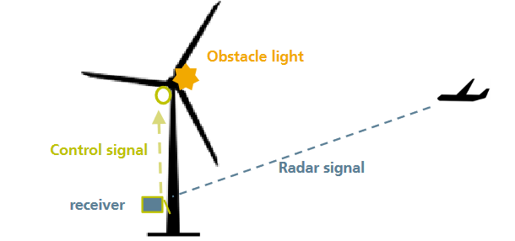
Figure Name: On-demand night-marking system

Few examples of companies implementing the on-demand night-marking systems are Quantec Sensors, Nordex, OCAS, Vestas InteliLight and Robur Wind.

  - Chapter Summary
This chapter deals with the used and alternative approaches in viewshed analysis. It elaborates the functions, applications and limitations of the QGIS and ArcGIS tools clearly differentiating them.

Chapter 4 Methodology

4.1 Extraction of Topographic Features
In terms of accuracy and reality of the output of visibility analyses, the quality of input digital elevation model is the most significant element. DEM’s are often used to characterize elements of the real surface they represent. Characterizations may be relatively low-level properties, here referred to as morphometric parameters such as slope magnitude, slope direction and slope convexity. These parameters may be used to identify following morphometric features: peak, ridge, pass, plane, channel, or pit.
Pits, peaks, and passes are point-based features:
- A pixel is classified as a pit when it has a concave curvature in all directions, thus it is lower in elevation than its surrounding neighbors.
- A pixel is classified as a peak when it has a convex curvature in all directions, thus it is higher in elevation than its surrounding neighbors.
- A pixel is classified as a pass when it has one convex curvature and one concave curvature. It lies within a local convexity that is orthogonal to a local concavity.
Channels and ridges are line-based features:
- A pixel is classified as a channel when it lies on a sloping surface that is concave in the orthogonal direction.
- A pixel is classified as a ridge when it lies on a sloping surface that is convex in the orthogonal direction.
Finally, a pixel is classified as a plane if it lies on a surface of constant elevation, where the surface is neither convex nor concave.
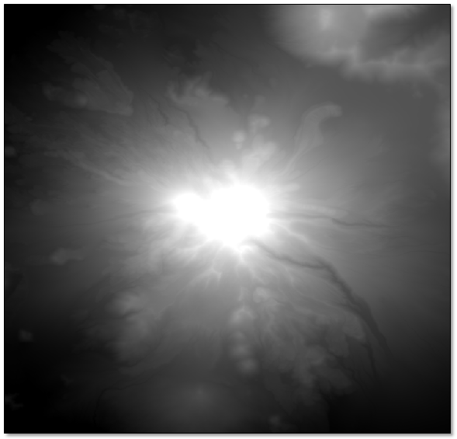
Figure Name: Sample Digital Elevation Model
The above diagram depicts the sample Digital Elevation Model, available from the U.S. Geological Survey. The resolution is 1/3-arc seconds with a pixel size of 0.00009259 degrees.
Merge of DSM tiff files covering Germany
Transformation
(EPSG: 4326 -> EPSG: 32633)
DEM

Figure Name: Creation of Digital Elevation Model
In this project, the digital elevation model is created by the DSM based tiff files covering Germany and then merged into one tiff file and then it serves as the input for the viewshed analysis algorithm.
The point which must be taken care are the projections. Projections play an important role in the analysis of viewshed analysis. The map on a computer screen is represented in 2-Dimensional but as Earth is spherical in shape the analysis should be carried out in 3-Dimensional. After getting the merged tiff file then we need to change the projection of the merged file into the required projection which in our case is ESPG 32633 and the original projection of the merged tiff file was ESPG 4326. EPSG code is a unique identifier for different coordinate systems. It's a public registry of geodetic datums, spatial reference systems, Earth ellipsoids, coordinate transformations and related units of measurement. Each entity is assigned an EPSG code between 1024-32767.
QGIS offers the transformation of the projection from 2D to 3D. This is achieved by the GDAL function to transform the projection from EPSG: 4326 to EPSG: 32633. The difference between both of them are EPSG: 4326 uses a coordinate system on the surface of a sphere or ellipsoid of reference. EPSG: 32633 uses a coordinate system projected from the surface of the sphere or ellipsoid to a flat surface and has coordinates in meters.
As depicted in the above diagram, the Digital Elevation Model is created which is suitable for our application and acts as an input for the viewshed analysis algorithm by changing it into our required projection. It plays an important role because it contains all the morphometric properties and features. The analysis is made on the DEM to get the accurate results.

4.2 Implementation Approach
The implementation approach determined in this module describes the steps followed to get the desired output. The main step is to get the viewshed analysis and then to transform the data into a suitable way to display it on the visualization tool. This is achieved with the help of QGIS tools. The necessary libraries and packages are imported. The Python was preferred for the development of the viewshed analysis as its interpreted nature and advanced dynamic data manipulation features proved to be highly useful in the development process. A special Python module named NumPy was used to handle array operations necessary on the raster data. Since Quantum GIS uses Qt windowing toolkit from Nokia, special Python bindings of Qt was needed for the plugin. This binding has been provided by the PyQt project. For the geometry related operations such as polygon intersections, Quantum GIS provides the necessary interfaces by the use of the Shapely package for Python. Another important library used was GDAL/OGR Python bindings which handles many vector and raster data types including GeoTIFF.
The below diagram depicts the implementation approach followed. Starting from viewshed analysis calculation algorithm to displaying of the results on the visualization tool.
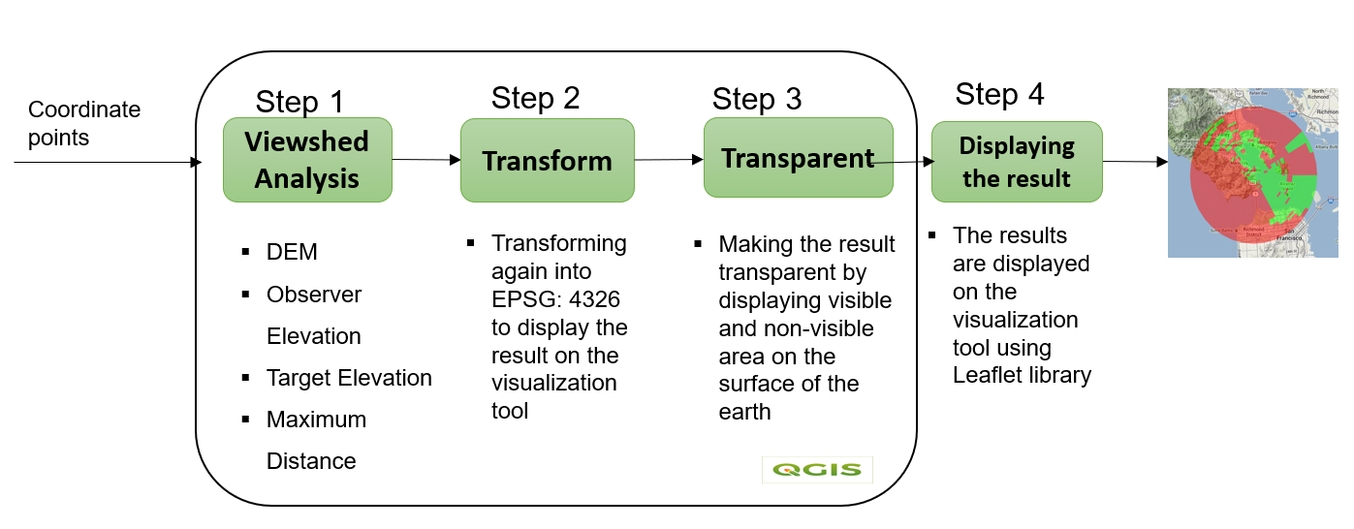
Figure Name: Implementation Approach

Step 1: Viewshed Analysis Calculation Algorithm:
The main approach followed was a custom algorithm written in Python, based on the viewshed analysis from the GRASS tool with the function r.viewshed computes the viewshed of a point on a raster terrain. It computationally analyzes the full surface raster.
The algorithm underlying r.viewshed minimizes both the CPU operations and the transfer of data between main memory and disk; as a result r.viewshed runs fast on very large rasters. It is possible to limit the region of the raster inspected by specifying various items in the feature attribute dataset, such as coordinates, observer elevation, Digital elevation model, target elevation, maximum distance to be covered, grass region parameter and flags c,b,r,e.

Observer Elevation
Coordinates
DEM

Target Elevation
-c, -r, -b, -e
Viewshed Analysis Algorithm

Maximum Distance
Grass Region Parameter

Figure Name: Viewshed Analysis Algorithm input parameters

The coordinate parameters are the receiver positions which are basically the antennas present outside the wind turbine. The coordinate points which are given to the viewshed analysis algorithm are taken from the database using a MySQL query. Care need to be taken while giving the coordinate points as input because the projection of coordinates need to be in the same projection of DEM. With the help of QGIS transform tool the points also can be transformed into the desired projection which is EPSG: 32633 in our case.
The Digital Elevation Model which was created by merging DSM tiff files is fed as an input to the viewshed algorithm. The analysis is made on the DEM and all the computations are based on the input parameters provided to the algorithm.
By default, the observer is assumed to have height 1.75 map units above the terrain. The user can change this using option observer_elevation. The value entered is in the same units as the elevation.
By default, the target is assumed to have height of 0 map units above the terrain. The user can change this using option target_elevation to determine if objects of a given height would be visible. The value entered is in the same units as the elevation.
By default, there is no restriction on the maximum distance to which the observer can see. The user can set a maximum distance of visibility using option max_distance. The value entered is in the same units as the cell size of the raster. The maximum distance limits the search distance when identifying areas visible from each observation point. Cells that are beyond a certain distance can be excluded from the analysis.
The change in the flag values such as -c, -r, -b, -r results in the different formats for the output raster map. -c considers the curvature of the earth (current ellipsoid). -r considers the effect of atmospheric refraction. -b determines the output format, if it is invisible then the value 0, if it is visible then the value is 1. -e determines the output format to NULL if it is invisible, otherwise it is the current elevation minus viewpoint elevation.

The Grass region parameter is used to limit the result only to the maximum distance area. This is achieved by providing the corner values of the output raster file by using the coordinate points and the maximum distance.

There are few optional input parameters where the default values are considered when not given any values. Those are:

Overwrite- which allows to overwrite the existing output files

Memory- The amount of memory to be used in MB and the default value is 500MB.

Directory- It is a String datatype used to hold the temporary files.

Refraction Coefficient- It is a float data type and the default value is 0.14286.

The output of the viewshed analysis is a tiff file consisting of the visible and the non-visible areas stored in a file location.

Step 2: Transform

The output raster map obtained from the viewshed analysis algorithm now needs to be transformed into the original projection that is EPSG: 4326. The reason for transforming back into its original projection is because the leaflet which is a JavaScript library used for the mobile friendly interactive maps, it has all the mapping features which helps to send the results which are in tiff format on the interactive maps. But the leaflet displays the data only in EPSG: 4326, for that reason the output raster tiff file needs to be transformed using QGIS tools.

Step 3: Transparent
The transformed tiff file is made to be transparent because the visible and non-visible areas need to be displayed along with underlying map.

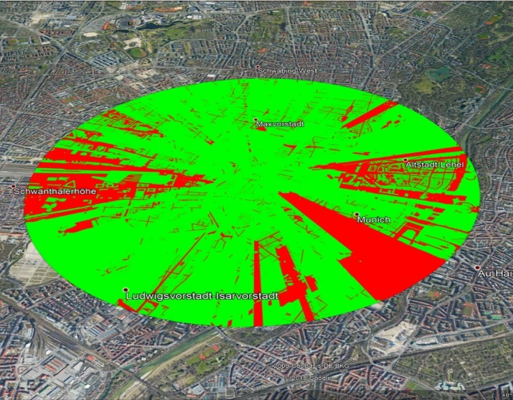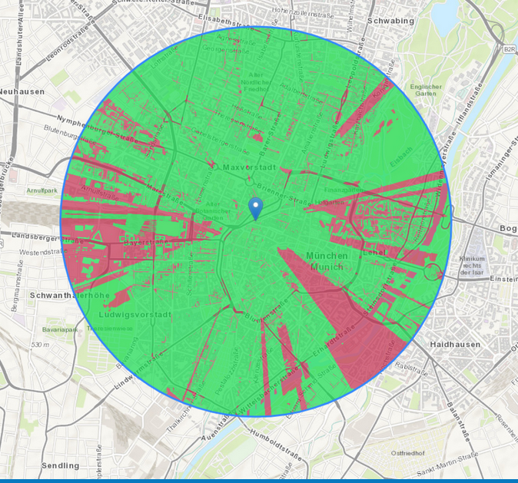

The above two diagrams depict the difference of the transparent tiff file and the non-transparent tiff file. With the transparent output raster image one can find the reason for the non-visible areas by looking at the tiff file on the map. The transparent tiff file is stored in a new file using the QGIS tools.

During the process of making tiff files transparent, the size of the newly formed tiff file need to be reduced. The general analysis results requires 1GB of storage for each observer point analysis, when the analysis of 20 observers is taken into account then the visual GUI displaying the results of viewshed analysis will crash.

With the help of various libraries present in QGIS, the process of viewshed analysis from the viewshed calculation to making the output raster file to transparent is carried out with the help of QGIS tools in python language.

STEP 4: Displaying the Results
The output from the step 3 is used to display the data on the map of a visualization tool. Here we introduce Leaflet, which is a light weight library for mobile-friendly interactive maps. The reason why it is termed as light-weight is it requires only 39 KB. Leaflet is designed with simplicity, performance and usability in mind. It works efficiently across all major desktop and mobile platforms, can be extended with lots of plugins, has a beautiful, easy to use and well-documented API and a simple, readable source code that is a joy to contribute to [41].
To install the latest stable version of Leaflet release can be done using straight away, by placing a few lines of code in the head of the HTML code. The other way is to use a JavaScript package manager. It can be done using the npm package manager, and a local copy of it could be fetched by npm install command.
The visualization tool is an assessment tool used to give detailed information regarding each element such as wind turbines, wind farms, LCU’s installed, receiver positions, radar etc. It is essentially used for developing and maintaining the wind farms.

4.3 Different tools of QGIS
Quantum GIS is a free and open-source software which stores, integrate and visualize spatial data. Over the years, it has become one of the most popular GIS tools with its many new features and its ability to run on multiple platforms. It provides a plugin 40 mechanism that supports extensions written in C++ and Python programming languages. The main reason for choosing QGIS over other GIS tools because it integrates its own toolset with those from other established open-source GIS such as SAGA, GRASS toolsets, as well as user created plugins, resulting in diverse functionality. Also, the significant user-base provides rapid updates, plugins and patches for the program, which in conjunction with online documentation can be consulted to perform or parametrize a variety of functions. In this section we are going to see the list of QGIS tools used in getting the desired output.
Functionality | Tool Name | Function Name
Merging of tiff files | GDAL | Merge
Transformation | GDAL | warpreproject
Viewshed analysis | GRASS | r.viewshed

Table Name: Different tools used
GDAL Merge: The main advantage of using GDAL (Geospatial Data Abstraction Layer) tools is because they are used for data translation and processing. GDAL/OGR is considered a major free software project for its "extensive capabilities of data exchange" and also in the commercial GIS community due to its widespread use and comprehensive set of functionalities. As a library, it presents a single abstract data model to the calling application for all supported formats. GDAL merge function will automatically mosaic a set of images. All the images must be in the same coordinate system and have a matching number of bands, but they may be overlapping, and at different resolutions. In areas of overlap, the last image will be copied over earlier ones.
The input parameters for this merge function is just the location of the DSM tiff files and by giving the address of the output file where it need to be stored, a merged raster tiff file is created with the execution of function at that particular location.
In our project, the DSM tiff files which cover Germany are merged into one tiff file so that whenever a new point is added in the database, the analysis can be made directly without creating a new DEM every time.
GDAL Warpreproject: Internally QGIS uses proj library for all the math behind coordinate transformations, so in case of any troubles with projections it is best to examine the PROJ representation within the object, as that is the representation that will be ultimately used. The gdalwarp utility is an image mosaicing, reprojection and warping utility. The program can reproject to any supported projection and can also apply GCPs stored with the image if the image is “raw” with control information.
The GDALwarp is used to transform the project into desired coordinate reference system where coordinate reference system is a specific map projection. It is also used to transform the coordinate points which are latitude and longitude points into same projection.
The input parameters for GDALwarp consists of source coordinate reference system and the target coordinate reference system. With these inputs one can easily transform their projects into different coordinate reference systems.
GRASS Viewshed: Geographic Resources Analysis Support System (commonly termed GRASS GIS) is a geographic information system (GIS) software suite used for geospatial data management and analysis, image processing, producing graphics and maps, spatial and temporal modeling, and visualizing. It can handle raster, topological vector, image processing, and graphic data. It runs on multiple operating systems, including OS X, Windows and Linux.
GRASS supports raster and vector data in two and three dimensions. The vector data model is topological, meaning that areas are defined by boundaries and centroids; boundaries cannot overlap within one layer. There is cooperation between the GRASS and Quantum GIS (QGIS) projects.
The function r.viewshed is used to compute the viewshed of a point on an elevation model. By considering all the parameters such as the observer height, target height, maximum distance to be covered, earth curvature, refraction coefficient the analysis is made. It does most of the heavy mathematical lifting. The GRASS function which integrates nicely into QGIS allowing you to use the algorithm without delving into the GRASS interfaces.
GDAL, GRASS are independent GIS tools which are executed on their own. But QGIS has GDAL, GRASS any many other GIS tools embedded in it, which helped to use those tools without any further installation, which was the main reason in choosing QGIS over ArcGIS.

4.4 Chapter Summary
This section provides an overview of the morphometric features that you can extract from digital elevation data. This chapter not only deals with the methodology of the viewshed analysis but also the detailed explanation of different types of tools used and how the Digital elevation model playing an important role in the viewshed algorithm.

Chapter 5 Observation Points

5.1 Selection of the Observation Points
An Observer point or a viewpoint is a point representing the surroundings or a continuous line. It is used as a control point for surveying the distance, elevational difference and vertical angle from the viewpoint and target (bottom and top). Therefore, the selection of a viewpoint is a very important step in analysis of viewshed.
The analysis is made with respect to the observer point, it represents which parts are visible from the observer point. The Observer points can be represented in the form of points, lines, polygons etc. When the observer features dataset is a point feature class, each observation point can have a unique set of observation constraints in the attribute table. When it is a polyline feature class, every vertex along an input polyline uses the same observation constraints contained in the polyline's record in the attribute table.
The number of observer points plays a crucial role in the terms of performance. The number of observer points is directly proportional to the execution time.
There are few methods proposed for the automatic extraction of the topographical features from DEM and TIN. But it is well known that these extraction methods are vulnerable to the noise in the DEM and, most importantly, have scale dependency limitation. There are few methods proposed for the automatic extraction of the topographical features from DEM and TIN. But it is well known that these extraction methods are vulnerable to the noise in the DEM and, most importantly, have scale dependency limitation.
The observation points in our project are directly taken from the database of the visualization tools which consists of all the information regarding the wind turbines coordinates, receiver position coordinates which are the antennas, LCU’s installed etc. The antenna’s coordinates are then used as an input for automated computation of viewshed from this location. The analysis is based on each point one after other with the same input parameters.
The viewshed analysis is not only performed on the points present in the database, but it can also be performed on a random position by just giving the coordinates of the point or by placing the observers on the terrain using the mouse. This means that whenever a mouse click
is registered on the screen, the world coordinates of that point are retrievable by
using the mouse event function from leaflet. The retrieved coordinates are transformed into the same projection as DEM.
Viewshed algorithms typically account for the height above the ground or offset of the observer and target objects in visibility calculation.

5.2 Elevation of Observation Points
The altitude of the observer above the terrain plays an important role in the computation of viewshed analysis. After the selection of the observer or viewpoints, as the common sense sug-gests, visibility can change completely, sometimes even only if we consider two differently tall people. When they observe an object, this can be seen only from the taller and not from the shorter one, because of obstacles to sight which can exist between shorter observer and object.
In order to define the elevation of an observer point, the user can define an offset value describing the height of the observer or target features above the surface elevation. For example, a ground antenna may have a constant offset value of two feet. Since a remote-sensing airplane is flying at a constant altitude, while the ground below is constantly changing elevation as its position changes, using a constant offset value for the flight path would inaccurately represent the airplane’s location.
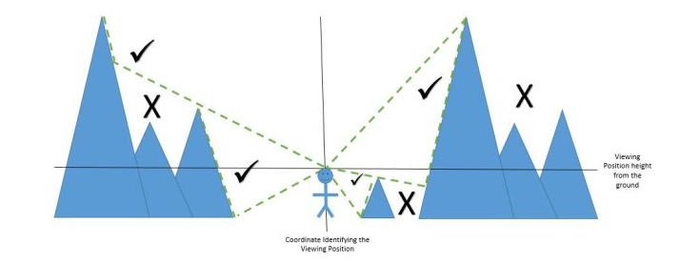
Fig name: Observer Point
One can control how much to offset the observation point (for example, the height of the tower), the direction to look, and how high and low to look from the horizon.
The Observation point in our project is elevated to the height of the windfarms. The main reason for giving the height of the wind farm which is 50m is because the observation points which are on the terrain level won’t be visible from all other locations. The elevation plays an important role as the change in the value of the elevation height results in the increase or decrease of the visibility. As shown in the above figure if the height of the person is increased to 50m then he can have the maximum visibility. If the observer height is taken as the surface of the terrain, then the visibility achieved will be minimum.
Based on the requirement, the elevation of the observer points differs. It can be 2m, 10m or even 100m. The analysis can be made on a watch tower, cell phone tower or even important landscapes.

5.3 Elevation of the Target Points
Every pixel point which is used for the computation of viewshed to produce a visibility index is in turn considered as a target point. The analysis is carried out to see whether the target is visible or not from the specific observer point. If it is visible, the pixel is allocated a colour value which is same for all visible pixel points.
The target height denotes the height which needs to be elevated on each point on the terrain above the ground surface. The ground level target points result in the least visibility. As shown in the below figure, the difference in the elevation of the target points plays an important role in visibility analysis as the output changes with the change in the elevation height. The increase in the target elevation leads to many visible points.
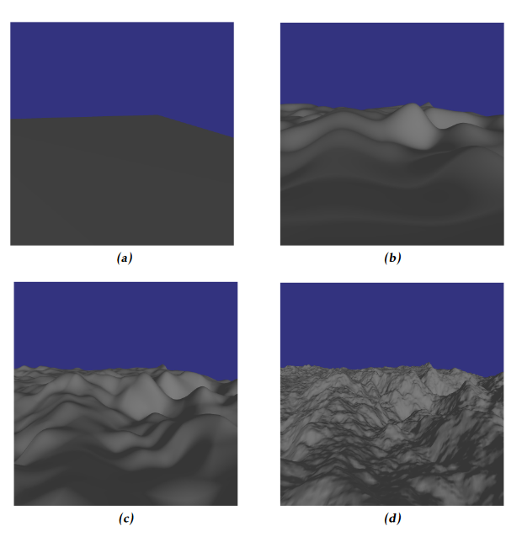
Figure Name: Elevation of target height with different values

In our study, the terrain points are elevated to the height of the 2m with respect to the height of a person. The main reason for taking a person height into account because the analysis is made assuming a person standing at all the points on the terrain and checking whether the wind turbine is visible from that specific position or not. This analysis is essential because the altitude of the aircraft varies from one to other. The locations at higher elevations are probably able to see a larger proportion of the surrounding sky than sites that are at lower elevations. Therefore, by considering the human height, one can be sure that an aircraft signal can be easily detected by the antenna.
The target height can be varied from one application to another. It can be terrain level in few cases and in other cases it can be 8m, 15m etc.

  - Chapter Summary
This chapter deals mainly concentrates on the observation points and target points and also the need of elevating the target and observation points which ultimately results in the increase of the visibility of a point.

Chapter 6 Discussion

Visibility analysis has become one of the most used geospatial tools in recent years. As the quality of the digital elevation data and the available computational power increased, more and better uses for visibility have been found. Viewshed analysis allows to understand which pixel is visible from an observation point, located in a certain area with known morphology. Therefore, in this analysis the input datum is a point pattern, while the output is a grid containing numerical information about target visibility. Exploring the functionality of QGIS tools proved to be very rewarding.
The customized python algorithm was developed by the methods based on the QGIS tools. In order to execute the viewshed function, we need to the setup the following environment for the execution of viewshed analysis.

Software | Version
Quantum GIS | 3.18.3
Python | 3.9
PyQt | 5.15
Visual Studio Code | 1.58
NumPy | 1.21.0

Table Name: Software setup for the development
The entire development is carried in Windows operating system. QGIS has many features, and it has the ability to run on multiple platforms. All the software were installed with Win64 version. The reason for choosing python is because of its interpreted nature and advanced dynamic data manipulation features.
The main parameter which needs to be taken care is the size of the tiff file. The viewshed analysis results in huge file which are up to 1GB. If the same size file for one observer is used to display on the visualization tool then then for 20 observers it would be 20Gb which results in the crashing of the visualization tool. Measures need to be taken in cutting the size of the tiff files to Kb or Mb size for the successful display of output on the GUI without crashing.
Let us now discuss about some of the pros and cons of the QGIS. The main purpose of QGIS is to edit, monitor and also analyze the geospatial data. The reason why it is popular is because it is open source, and a free GIS which is used in both i.e. for viewing and also for analyzing the geospatial data. A varied database for different functionalities, applications and setup can be processed. Along with this different type of plugins can be used as an extension to QGIS. Anything that is not available locally or natively is available as a plugin. Some additional functions such as editing, creating, managing and exporting can also be done. In addition to this, it is compatible with almost all the Operating system which exists in the market.
QGIS is very efficient in producing some polished geospatial data, also for conversion of one data format to any other formats.
QGIS allows users to View and also Overlay raster and vector data. A good amount of digitizing platforms are also available such as GRASS vector layers and also OGR compatible format. It also consists of some additional useful features such as vector analysis, geometry tools, sampling and geo processing.
As we have already discussed the pros of QGIS, there also exists some limitations. The map creating features are sometimes cumbersome and also takes more computing power from ArcGIS. The user interface allows users to add the labels manually to some of the relevant items because it becomes sometimes too convoluted.

Chapter 7 Results

The custom python algorithm is faster for all study areas, especially at finer raster resolutions.
The study is to determine the viewshed for the receivers. The main output is a binary viewshed that’s the visible and the obstructed for a point within the radius. The software automatically computes the results of the analysis by taking all the input values.
The below table determine the input parameters used for this study. As mentioned in the above chapters, the input parameters fed into viewshed analysis can change the output. Change in these values drastically change the entire result.

Observer Height | 50m
Target Height | 2m
Maximum Distance covered | 25000m
Projection | EPSG: 32633

Table Name: Software parameters for the test case
The execution time plays an important role in any of the algorithm. The greater the observation points, the greater is the execution time.
Execution time for the viewshed function:
Distance Covered  (m) | No. of Observers | Average run time (seconds)
25000 | 1 | 52
25000 | 5 | 260
25000 | 18 | 936

Table Name: Execution time of the viewshed function
The output on the final GUI is the representation of the visible areas on the map as shown in the below figure. Though the algorithm takes only one observer point at each time, the result is displayed with all the observer points.
There can be different shades of red in the below picture, that when the target points of two different observer points coincide. The light version of red represents the analysis of only one observation point. The intensity increases with the coincidence of more observation points.

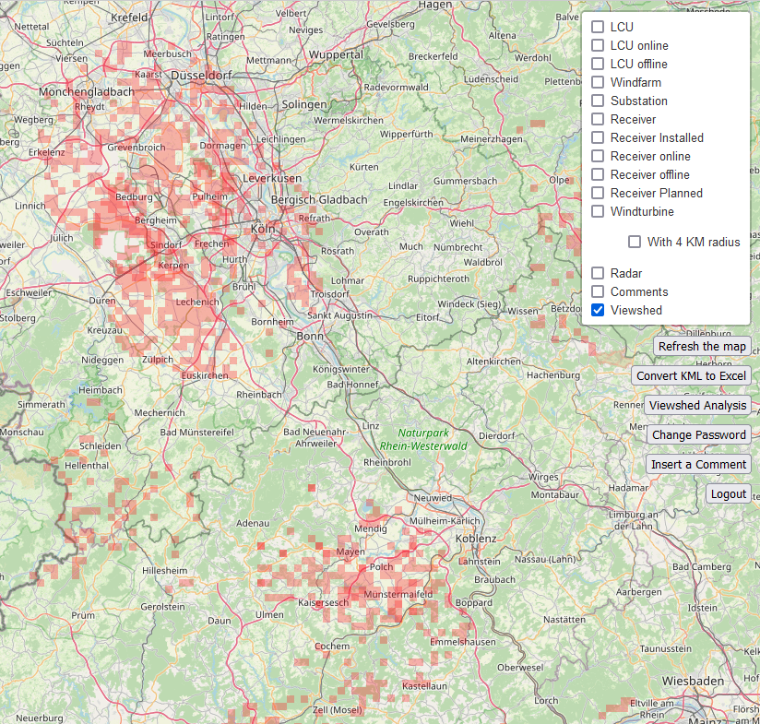
Figure Name: Results on Visual GUI

The analysis can be also performed on a random position to check the visibility of the terrain.
In the below figure we can clearly the viewshed analysis on a random position which is given with the mouse click.
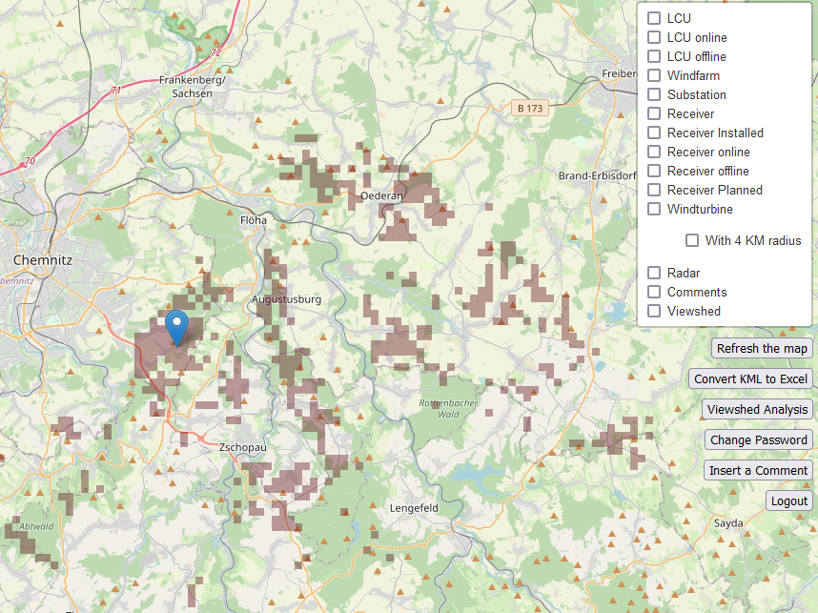
Figure Name: Random position analysis

The analysis of receiver position results in red color where as the analysis for the random position results in brown colour in order to differentiate between two analysis, the colour is changed.

Chapter 8 Conclusion

Visibility analysis has become one of the most geospatial tools in recent years. The results of this exploration of visibility analysis methods are informative in a variety of ways. In this paper, starting from the consolidated literature concerning viewshed analysis, a more detailed kind of viewshed has been developed using QGIS tools.
The strong correlations can be observed between input parameters and execution time are related to the number of times the basic calculation is performed and how long that calculation takes to complete. Repeated iterations of the former process take longer to complete. This concept can be extended to other visibility analysis methods: if the basic calculation is simpler, the execution time is faster.
Given the significant influence of DSM accuracy on visibility accuracy, it is worth emphasizing the importance of choosing an appropriate elevation surface. As the quality of the digital elevation data has increased more these years and better results for visibility have been found.
The viewshed analysis of all the receivers helps to identify the areas which are visible and not visible with in the radius of 25kms. This helps to send the signal to the LCU, and the light can be toggled in the vicinity of the flying objects. The results of the viewshed analysis are used to give the results for a new receiver where the user want to check for the optimal position. The QGIS tools which are implemented in Python helps to execute the algorithms in a faster way.
In this work, we revisit a core subroutine (i.e., visibility analysis) in Geographic Information System. We firstly propose a comprehensive computation framework for visibility analysis, then making the result compatible to display it on a visible GUI. Finally, we demonstrate the effectiveness and efficiency of our proposed computation frameworks.
The work in this thesis was focused to perform viewshed analysis as a helpful tool for the on-demand night-marking systems.
One of the shortcomings of the viewshed functions in current GIS is that they are not able to solve optimization problems, such as identifying an optimal set of viewpoints. It would be a trial-and-error method in finding the areas with maximum visibility.

Conclusions derived from this study are:
The proposed methodology has been successfully applied to the study area. Viewshed analysis to provide a useful mechanism to understand the visibility characteristics over a terrain.
Automation of the analysis improves the use of viewshed analysis in all the fields.
Decrease in the execution time results in the efficiency of the algorithm.
This study has attempted to integrate techniques already present within the capabilities of the GIS with a diverse area of research. In exploring the avenue of research of applying viewshed analysis to the receiver positions, significant results have been achieved
Chapter 9 Future Work

In the future, the viewshed analysis can be performed not only in Germany but also all over the world. The reason for taking the wind turbines only in Germany is because the digital elevation model consists only of the tiff files in Germany.
Now the viewshed analysis is performed for all the receivers with the help of a button present on the WPAT tool. Later it can be automated without the help of the button, and it automates the process every night so that if there are additional receivers added, it displays the output with all the receivers added recently.
Viewshed analysis is not limited only to binary viewshed where analysis made on one observer point but it can be made with respective to multiple observer points by combining the different binary viewsheds and to form cumulative viewshed.
First, there is clearly scope for more work on predicting which parts of the terrain are likely to make good candidate points. These developments open up the prospect of developing a system which is capable of producing solutions to the multiple viewpoint problem in a relatively short time, possibly even in real time. At this point the development of a graphical user interface for such a system would also become a topic for further work.

Bibliography

- Jakab, Imrich & Petluš, Peter. (2018). THE USE OF VIEWSHED ANALYSIS IN CREATION OF MAPS OF POTENTIAL VISUAL EXPOSURE.
- Z. Cuckovic, “Advanced viewshed analysis: a Quantum GIS plug-in for the analysis of visual landscapes,” Journal of Open Source Software, 2016, vol. 1, no. 4, pp.32.
- Y. Zhi, L. Wu, Z. Sui and H. Cai, "An improved algorithm for computing viewshed based on reference planes," 2011 19th International Conference on Geoinformatics, 2011, pp. 1-5, doi: 10.1109/GeoInformatics.2011.5980948.
- C. Şeker, “Weighted multi-visibility analysis on directional paths,” MS thesis. Middle East Technical University, 2010.
- V. Saxena, P. Mundra and D. Jigyasu, “Efficient Viewshed Analysis as QGIS Plugin," in 2nd International Conference on Advances in Computing, Communication Control and Networking (ICACCCN), 2020, pp. 957-961.
- C. A. H. A. Jan, “Line of Sight Analyst: ArcGIS Python Toolbox for visibility analyses,” Geographia Cassoviensis, Jan 12, 2019.
- A. Koltsova, B. Tuncer, and G. Schmitt, “Visibility Analysis for 3D Urban Environments,” 2013.
- P. Bhaurah, Planning tank. (2021). Accessed: July 6, 2021. [Online]. Available: http://planningtank.com/geographic-information-system/differences-qgis-arcgis
- Yi. Qiang, S. Shen, and Q. Chen, "Visibility analysis of oceanic blue space using digital elevation models," Landscape and urban planning 181 Jan. 1, 2019, pp. 92-102.
- Cloudeo.group. High-precision digital terrain Visibility Analysis - cloudeo. 2021. Accessed July 6, 2021]. [Online]. Available: https://www.cloudeo.group/visibility-analysis
- D. Nutsford, F. Reitsma, A. Pearson, and S. Kingham, “Personalising the viewshed: Visibility analysis from the human perspective,” Applied Geography, 2015, 62, pp. 1-7.
- Y. Zhi, L. Wu, Z. Sui and H. Cai, "An improved algorithm for computing viewshed based on reference planes," 2011 19th International Conference on Geoinformatics, 2011, pp. 1-5, doi: 10.1109/GeoInformatics.2011.5980948.
- D. Wheatley, “Cumulative viewshed analysis: a GIS-based method for investigating intervisibility, and its archaeological application,” Archaeology and geographical information systems: a European perspective, 1995, pp. 171–185.
- E. Pfister-Altschul, “Comparison of Ground-to-Air Visibility Analysis Methods,” MS. Thesis, 2014.
- D. Maria, N. Gabriele and M. Beniamino, “Identifying Viewshed: New Approaches to Visual Impact Assessment,” 2011.
- S. Popelka and V. Vozenilek. "Landscape visibility analysis and their visualisation." ISPRS Arch 38.4, 2010.
- K. Young-Hoon, R. Sanjay and W. Steve, "Exploring multiple viewshed analysis using terrain features and optimisation techniques," Computers & Geosciences 30.9-10, 2004, pp. 1019-1032.
- R. Sanjay, "Fast approximation of visibility dominance using topographic features as targets and the associated uncertainty," Photogrammetric Engineering & Remote Sensing 69.8, 2003, pp. 881-888.
- A. Koltsova, B. Tuncer, G. Schmitt,“Visibility Analysis for 3D Urban Environments,” 2013.
- I. Jakab and P. Petluš, “The use of viewshed analysis in creation of maps of potential visual exposure,” 2018.
- M. Ogren Benjamin, “ RA570 Advanced GIS: Wind Farm Viewshed Analysis Using Spatial Analyst and 3D Analyst,” Department of Resource Analysis, Saint Mary’s University of Minnesota, Winona, MN 55987.
- G. Sullivan Robert, "Wind turbine visibility and visual impact threshold distances in western landscapes," National Association of Environmental Professionals 37th Annual Conference, May. 2012.
- S. Taeger and U. Lothar, "Beyond Viewshed Analysis: Extended Approaches to Visibility Analysis in Energy Transition Landscapes." Journal of Digital Landscape Architecture, 2018, pp. 60-67.
- G. Achilleos and A. Tsouchlaraki, "Visibility and viewshed algorithms in an information system for environmental management," WIT Transactions on Information and Communication Technologies 32, 2004.
- P. Yang, S. Putra and W. Li, “Viewsphere: A GIS-Based 3D Visibility Analysis for Urban Design Evaluation,” Environment and Planning B: Planning and Design, 2007, vol. 34, pp.971-992.
- S. Topouzi, "The application of viewshed analysis in greek archaeological landscape," 6th Annual Meeting of the European Association of Archaeologists, 2000.
- L. Liu, L. Zhang, J. Ma, L. Zhang, Z. Liang, Z. XingMing , X. ZhiQiang and L. Yang, “An improved line-of-sight method for visibility analysis in 3D complex landscapes,” Science China Information Sciences, 2010, vol. 53, pp. 2185-2194.
- E. JOHANSSON and L. Jacob, “Distributed viewshed analysis an evaluation of distribution frameworks for geospatial information systems,” MS thesis, 2016.
- A. J. Sanchez-Fernandez, "A data relocation approach for terrain surface analysis on multi-GPU systems: a case study on the total viewshed problem," International Journal of Geographical Information Science, 2011, vol. 35.8, pp. 1500-1520.
- M. Özkıdık, “Improved viewshed analysis algorithms for avionics applications,” MS thesis, Middle East Technical University, 2019.
- F. Marco, “A Formal Fault Model for Component-based Models of Embedded Systems,” Phd thesis, Technische Universität Chemnitz, 2007.
- D. Beer, S. Höhne, H. Petersohn, T. Pöhnitzsch, G. Rünger, and M. Voigt, "Designing a distributed workflow system for e-government," in Proc. of the 24th IASTED Int. Conf. on Modelling, Identification, and Control, ACTA Press, Innsbruck, Austria, 2005, pp. 583-588.
- S. Shadi, S. Hadi, M. A. Nazari, W. Hardt, "Outdoor navigation for visually impaired based on deep learning," in Proc. CEUR Workshop Proc. 2019, vol. 2514, pp. 97-406.
- Wood, J. "Scale-Based Characterizations of Digital Elevation Models." In Innovations in GIS 3. Taylor & Francis, 1996.
- DODD, Howard Mannin. (2001), The Validity of Using a GIS Viewshed Function [online]. Blacksburg : Blacksburg, 49 p. Diploma thesis. Faculty of the Virginia Polytechnic Institute.
- GIS Viewshed Analysis, [cit. 2010-04-29]. [online]:<http://en.wikipedia .org/wiki/GIS_Viewshed_Analysis>.
- Analýzy viditelnosti. (2009). Analýzy viditelnosti.[online]: < http://www.geoinformatics. upol.cz/file/vyuka/ml2.pdf>.
- https://core.ac.uk/download/pdf/158278714.pdf
- https://patentimages.storage.googleapis.com/a6/ac/0a/817d6779a552c7/US9041708.pdf
- https://landscapearchaeology.org/2018/depth-below-horizon/
- https://leafletjs.com/

